**Real-time Earthquake Data Processing and Visualization**

**Group – 4**

Sai Sankeerth Thallapally, U00861167

*Computer Science, University of Memphis*

Rahul Penchala, U00869508

*Computer Science, University of Memphis*

Rohan Reddy Katkuri, U00858581

*Computer Science, University of Memphis*

**Dr. Xiaofei Zhang**

*Department of Computer Science,*

*University of Memphis*

Table of Contents

Abstract 5

**Real-time Earthquake Data Processing and Visualization** 6

Objectives 6

Scope 6

Methodology 7

Data Acquisition and Database Initialization 7

Database Setup: 7

Data Retrieval: 7

Data Insertion: 8

Data Warehousing 8

Warehouse Database Setup: 8

Data Transfer: 9

Data Visualization 9

Map Generation: 10

Map Output: 10

Data Archival and Management 11

Backup and Archival: 11

Database Clean-Up: 11

Automation and Scheduling 11

Cron Jobs: 11

Backup Scheduling: 11

Remote Data Access and Transfer 12

Secure Copy Protocol (SCP): 12

Command Execution: 12

Authentication: 12

Integration in Workflow: 12

Conclusion 13

Future works 14

Scalability 14

Real Time Streaming 14

Advanced Data Analysis 14

User Interface 14

Internet of Things (IoT) Integration 14

References 15

Figure 1: Running the fetcher script to get the data from API 8

Figure 2: Data warehousing script 9

Figure 3: Map retrieved from raspberry pi to my local machine using scp protocol 10

Abstract

The rise, in the number of devices that perform edge computing has opened up possibilities for processing and visualizing data in time. In this project we make use of a Raspberry Pi, which's a powerful device for edge computing to create an advanced database system for monitoring earthquake data in real time.

The system works by retrieving seismic activity data from the United States Geological Survey (USGS) API, processing and storing that data directly on the Raspberry Pi and presenting it on a map that shows geographical locations. By carrying out these tasks on the Raspberry Pi itself we reduce the time delay typically associated with centralizing data processing and allow for visualization of earthquake incidents at a level. This approach not provides access to potentially life saving information but also serves educational and scientific purposes by showing real time seismic activities from around the world. Moreover the system can be accessed over a network allowing users to view updated earthquake visualizations, from any computer connected to the network as the Raspberry Pi.

This project serves as a demonstration of how edge computing can be applied to analyze real time data and showcases the advantages of data processing systems.

Real-time Earthquake Data Processing and Visualization

This project leverages the capabilities of edge computing by using a Raspberry Pi to develop a cutting edge database system, for monitoring earthquake data in time. The objective is to offer a localized solution that enables processing and visualization of data. The purpose of this system is to connect the collection of data with user friendly access empowering individuals and communities with up, to the minute seismic information.

## Objectives

The primary objectives of the project are:

* To set up a Raspberry Pi as an edge computing device capable of processing and storing real-time earthquake data.
* To develop a script that automatically fetches and stores earthquake data from the USGS Earthquake API into a local database.
* To visualize the data on an interactive map that can be accessed within the local network, providing a user-friendly interface for data interpretation.
* To demonstrate the capabilities of the Raspberry Pi in handling real-time data processing tasks traditionally reserved for more powerful computing systems.

## Scope

The scope of this project encompasses the following:

* Setting up and configuring the Raspberry Pi with necessary software and network access.
* Implementing a Python-based data acquisition system that interacts with external APIs to fetch earthquake data.
* Designing and maintaining a local SQLite database to manage the data effectively.
* Creating a web-based visualization tool to represent the seismic data graphically on a map.
* Enabling network access to allow visualization on other devices connected to the same network as the Raspberry Pi.

# Methodology

The methodology of this project encompasses a complete cycle of data acquisition, processing, visualization, and management within a self-contained Raspberry Pi environment. The system is designed to harness real-time earthquake data, offering insightful visualizations and efficient data handling. Below, we expound on the sequence of operations and the scripts that facilitate them.

## Data Acquisition and Database Initialization

The foundation of our project is laid by establishing a reliable data acquisition system. We have scripted the **earthquake_fetcher.py** to interact with the USGS Earthquake API, fetch data, and instantiate our primary database.

### Database Setup:

* + The script initiates by creating an SQLite database named **earthquakes.db**.
  + A table named **earthquakes** is defined to store essential attributes of seismic events such as ID, magnitude, location, time, latitude, and longitude.

### Data Retrieval:

* + Employing the **requests** library, the script reaches out to the USGS Earthquake API endpoint.
  + Data for the past 30 days is requested, with a minimum magnitude threshold to filter significant events.

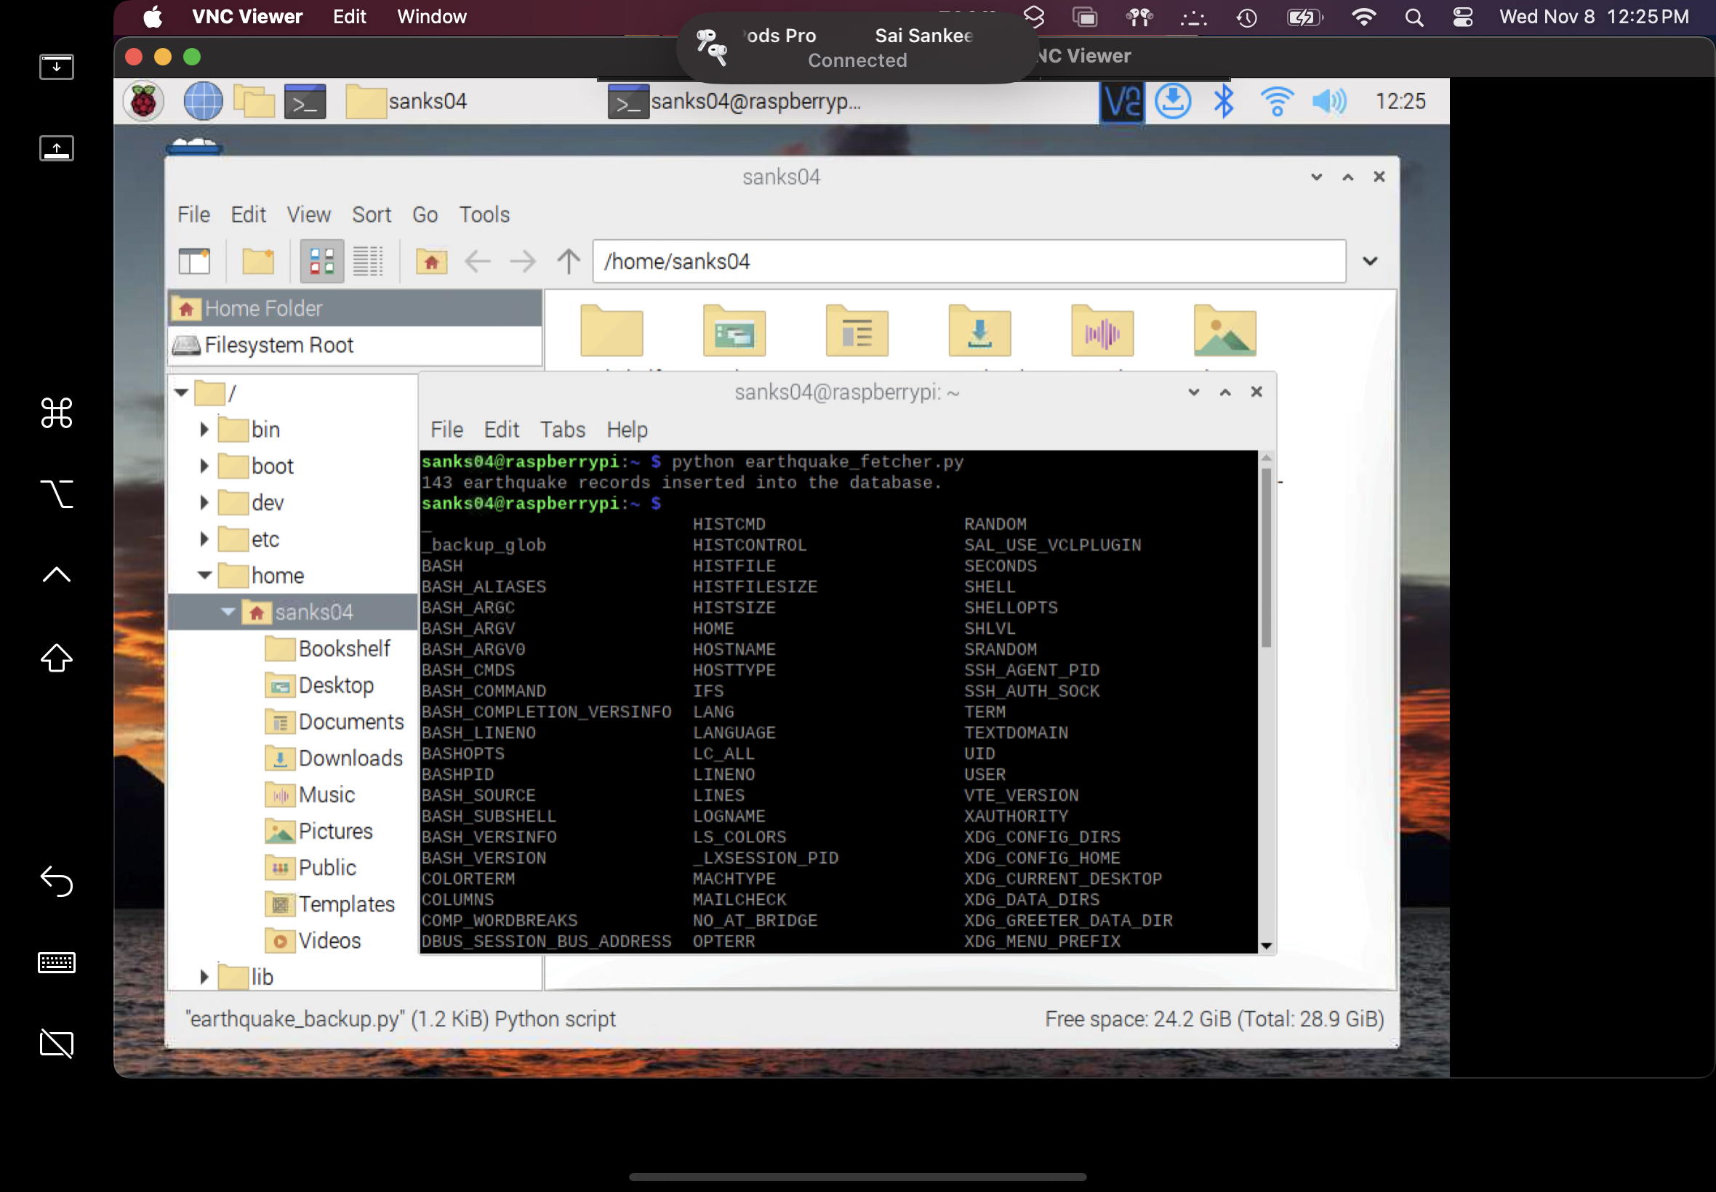

Figure : Running the fetcher script to get the data from API

### Data Insertion:

* + Extracted JSON data is parsed, and relevant information is inserted into the **earthquakes** table.
  + The insertion process is logged, providing a count of records added to the database.

## Data Warehousing

To safeguard data and structure it for potential analytical processes, we employ a data warehousing approach.

### Warehouse Database Setup:

* + A separate database, **earthquake_dw.db**, is created to act as a data warehouse.
  + A corresponding table, **earthquakes_dw**, mirrors the structure of the **earthquakes** table to store historical data.

### Data Transfer:

* + Data from the operational database (**earthquakes.db**) is batch transferred to the warehouse database (**earthquake_dw.db**) to maintain a historical record.
  + This ensures that data is retained for longitudinal analysis and backup.

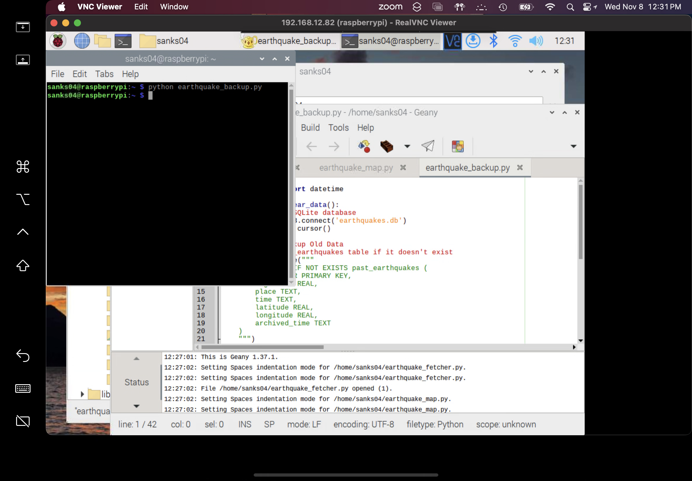

Figure : Data warehousing script

## Data Visualization

Visualization is a critical aspect that transforms data into a comprehensible and interactive format.

### Map Generation:

* + The **earthquake_map.py** script reads data from **earthquakes.db** and utilizes the **folium** library to plot earthquake events on an interactive map.
  + Each event is represented by a marker, the size and color of which are determined by the earthquake's magnitude.

### Map Output:

* + The map is outputted as an HTML file, **earthquake_map.html**, which can be hosted locally or on a web server for broader access.

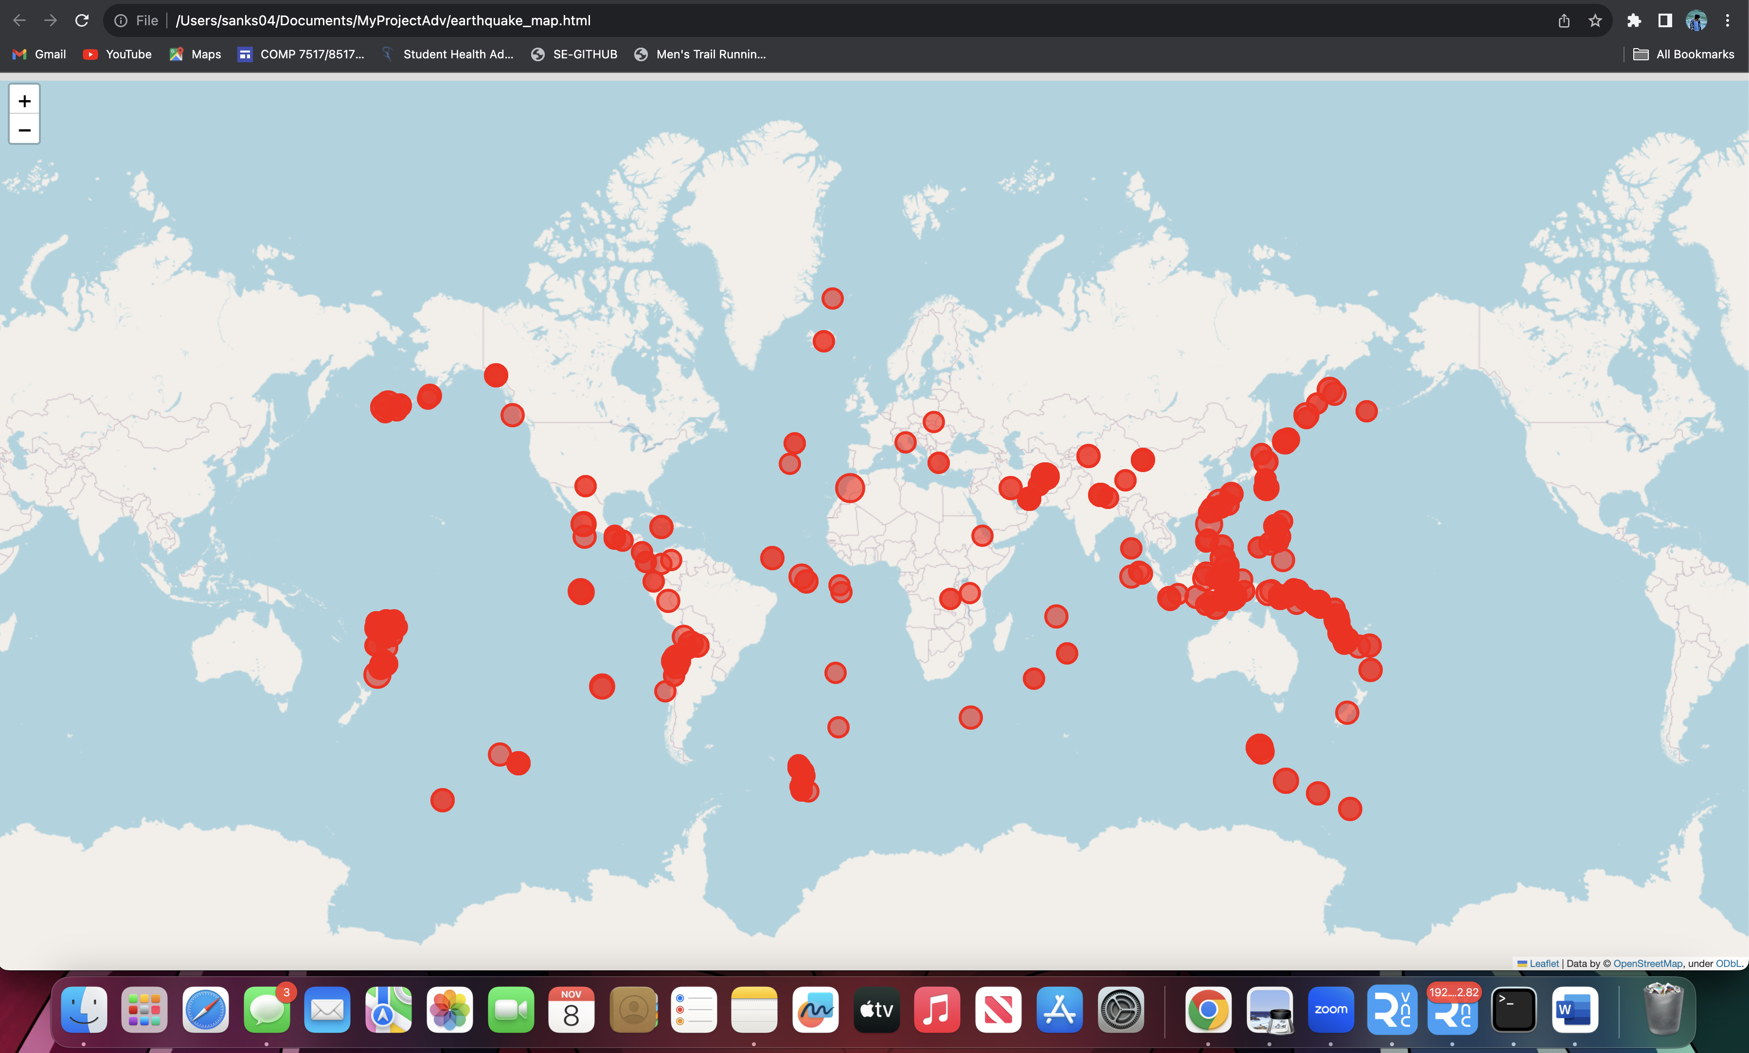

Figure : Map retrieved from raspberry pi to my local machine using scp protocol

## Data Archival and Management

Given the continuous influx of data, it's imperative to manage the database's size and relevance.

### Backup and Archival:

* + The **earthquake_backup.py** script is tasked with data retention and archival.
  + It creates a table **past_earthquakes** to archive old records and appends an archival timestamp to each record.

### Database Clean-Up:

* + Post-archival, the script clears the **earthquakes** table, ensuring that the operational database remains optimized for new data.
  + This process allows for efficient performance and storage management.

## Automation and Scheduling

Automation scripts ensure that the entire process is seamless and does not require manual intervention.

### Cron Jobs:

* + The Raspberry Pi is configured with cron jobs to run the **earthquake_fetcher.py** and **earthquake_map.py** scripts at regular intervals.
  + This setup maintains the database with the latest data and updates the visualization accordingly.

### Backup Scheduling:

* + Regular intervals are also established for the **earthquake_backup.py** script to manage data archival and retention.

## Remote Data Access and Transfer

A crucial component of the system's design is the ability to securely transfer data outputs, specifically the generated earthquake visualization maps, from the Raspberry Pi to a local machine for broader access.

### Secure Copy Protocol (SCP):

* + The Secure Copy Protocol (SCP) is utilized to transfer the **earthquake_map.html** file from the Raspberry Pi to a local machine.
  + This process is facilitated by the command line, leveraging SSH for secure data transmission.

### Command Execution:

* + The command **scp sanks04@192.168.12.82:/home/sanks04/earthquake_map.html /Users/sanks04/Documents/MyProjectAdv/** is executed on the local machine.
  + It specifies the username (**sanks04**), the Raspberry Pi's IP address (**192.168.12.82**), and the file path on both the Raspberry Pi and the local system.

### Authentication:

* + For the SCP command to access the Raspberry Pi, the correct password for the **sanks04** user account is required.
  + This ensures that data transfer is secure and only accessible to authorized users.

### Integration in Workflow:

* + The SCP command can be integrated into a script that runs after the **earthquake_map.py** script has completed, automating the transfer process.
  + Alternatively, a cron job could be set up to periodically check for new **earthquake_map.html** files and transfer them accordingly.

# Conclusion

The main objective of our project was to create a system that can visualize and analyze earthquakes in time using a Raspberry Pi as a device, for edge computing. Throughout the project we successfully developed a solution that retrieves, processes, stores and displays earthquake data. To achieve this we wrote customized Python scripts that interacted with the USGS earthquake data API stored the data in a database and presented the results on a map.

By utilizing the Raspberry Pi we were able to demonstrate how edge computing devices can efficiently handle data processing tasks. The portability and efficiency of the Raspberry Pi made it an excellent choice for deploying an cost effective solution for real time analysis and visualization of data.

Our successful implementation of database backup techniques and strategies for storing data ensured not enhanced system performance. Also guaranteed data integrity and availability for historical analysis and reporting purposes. Additionally incorporating methods like SCP (Secure Copy Protocol) facilitated transfer of visual data from the Raspberry Pi to other devices, on the network ensuring accessibility of information to end users.

# Future works

To further enhance the projects capabilities and advance its evolution into a database system we propose several enhancements;

## Scalability

Introduce a distributed database system to effectively handle larger datasets and improve scalability. Explore the utilization of cloud services, for data storage and computation ensuring availability and fault tolerance.

## Real Time Streaming

Develop a real time data streaming solution using technologies like Apache Kafka and Apache Spark. This will enable processing and visualization of data.

## Advanced Data Analysis

machine learning algorithms to predict aftershocks following earthquakes or analyze patterns.

Harness graph databases to delve into complex relationships within seismic data.

## User Interface

Design a user web based interface that allows users to interact with the system customize preferences for data visualization and receive alerts for seismic events.

## Internet of Things (IoT) Integration

Integrate sensors to collect data such as temperature, pressure and humidity which may have correlations, with seismic activity. Implement edge computing algorithms that minimize latency and network load by processing data directly on the Raspberry Pi device.

# References

Burch, M., Tauroseviciute, I., & Guridi, G. M. (2022). Visual Analysis of Spatio-Temporal Earthquake Events. *VINCI 2022: International Symposium on Visual Information Communication and Interaction 2022*. <https://doi.org/10.1145/3554944.3554959>

Beroza, G. C., Segou, M., & Mousavi, S. M. (2021). Machine learning and earthquake forecasting—next steps. *Nature Communications*, *12*(1). <https://doi.org/10.1038/s41467-021-24952-6>

Design, implementation and performance of an edge computing prototype using Raspberry PIS. (2022, January 26). Retrieved from <https://ieeexplore.ieee.org/document/9720848>

Personal Edge Cloud using Raspberry Pi. (2020). *Xi’an Dianzi Keji Daxue Xuebao*, *14*(5). <https://doi.org/10.37896/jxu14.5/098>

Vyas, S., Tyagi, R. K., Jain, C., & Sahu, S. (2022). Performance Evaluation of Apache Kafka – A Modern Platform for Real Time Data Streaming. *2022 2nd International Conference on Innovative Practices in Technology and Management (ICIPTM)*. <https://doi.org/10.1109/iciptm54933.2022.9754154>